IE3-CO Lab Session #4: Preparation sheet
Surname, First Name | Group:
Ali Emami | # 3
This preparation sheet must be filled and uploaded to EMIL by every student before the lab session. Cooperation within the lab team (of 2-3 students) is possible (same solution). However, no cooperation across lab teams.

Question 1 (30 min):
The character ‘#’ is transmitted via a UART port in 7/O/2 format at 100kbit/s. Sketch the transmit signals at location A and location B as indicated in the figure below.
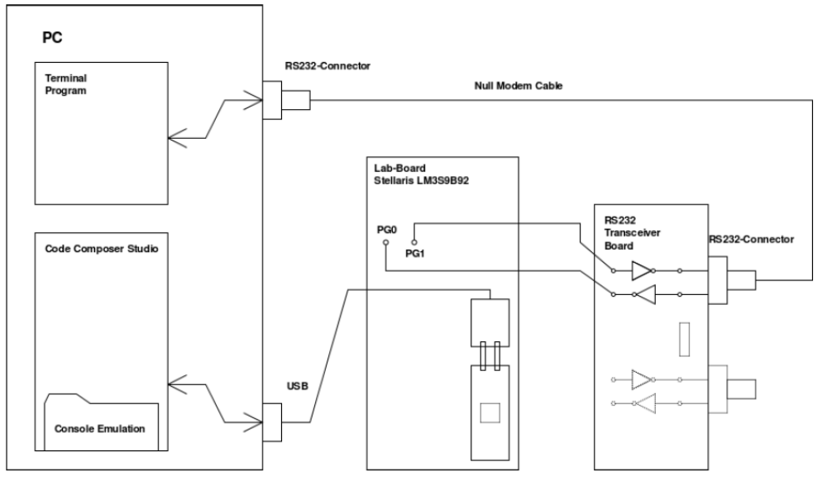
A
B
Which of the three UART Ports (0,1,2) is used below (explain your answer)?
Sketch of the transmit signal at location A:

Sketch of the transmit signal at location B:

Question 2 (45 min):
Draw the flow chart (NSD) for task 5 of the assignment sheet (incl. echo mode).

Question 3: (30 min)
Configure the UART registers incl. the bit rate divisor. Give calculation details for the bitrate divisor.

Question 4: (30 Min)
Write an initial C program for task 5 of the assignment sheet strictly following the specification in Question 2 above.

